5_3_Conditional_Expressions_Trushkova_M

**Vocabulary**

|  |  |
| --- | --- |
| DECODE | Compares an expression to each of the search values |
| Conditional expressions | An if-then-else expression whose value depends on the truth-value of a Boolean expression |
| CASE | Implements conditional processing within a SQL statement; it meets the ANSI standard |

**Try It / Solve It**

1. From the DJs on Demand d_songs table, create a query that replaces the 2-minute songs with “shortest” and the 10-minute songs with “longest”. Label the output column “Play Times”.

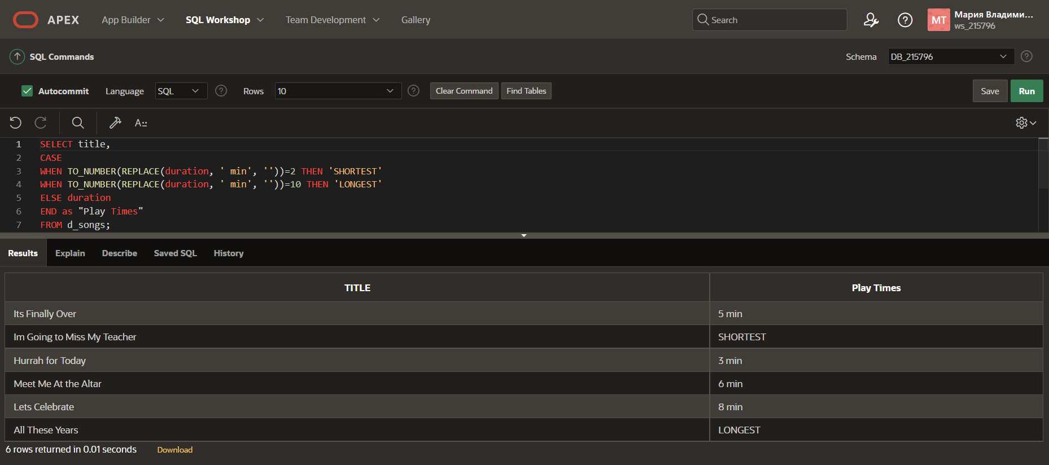

1. Use the employees table and CASE expression to decode the department id. Display the department id, last name, salary, and a column called “New Salary” whose value is based on the following conditions:

If the department id is 10 then 1.25 * salary

If the department id is 90 then 1.5 * salary

If the department id is 130 then 1.75 * salary

Otherwise, display the old salary.

1. Display the first name, last name, manager ID, and commission percentage of all employees in departments 80 and 90. In a 5th column called “Review”, again display the manager ID. If they don’t have a manager, display the commission percentage. If they don’t have a commission, display 99999

